TC-CMS-015
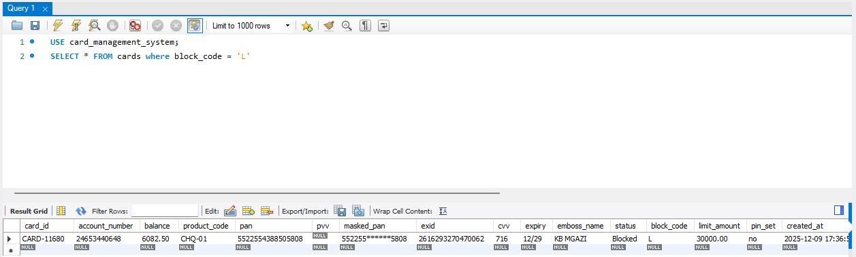
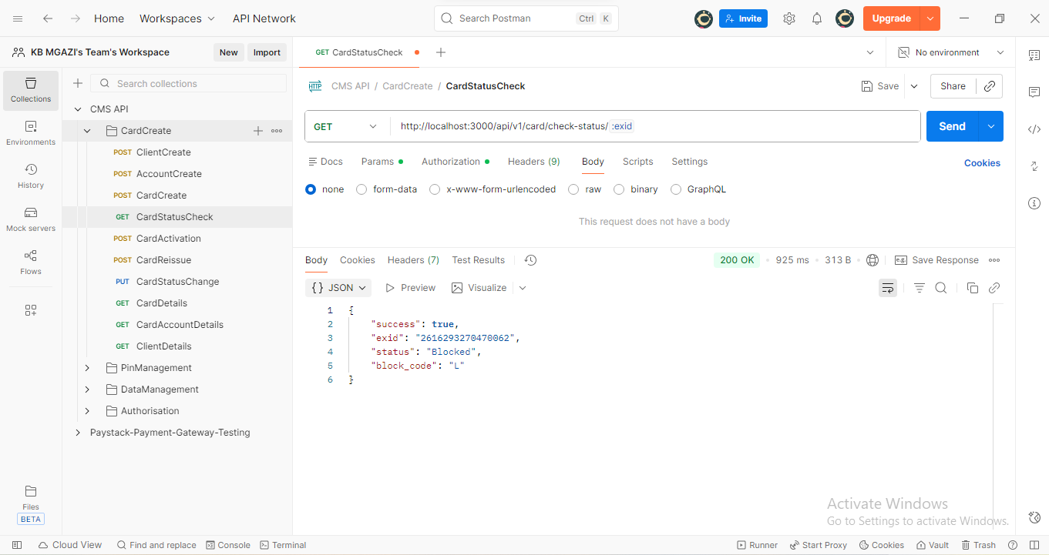
Response:
{
"success": true,
"exid": "2616293270470062",
"status": "Blocked",
"block_code": "L"
}

